Proposal to Provide Mobile Device Technical Empowerment Classes for Seniors

Prepared for Heron’s Key

Gig Harbor, WA

Prepared by

Claire Prendergast, Software Engineer

15 November 2018

TABLE OF CONTENTS

INFORMATIVE ABSTRACT 3

INTRODUCTION 4

Problem 4

Objectives 4

Solution 4

Background 5

Qualifications and Personal Experience 5

Research and Case Studies 5

Data Sources 7

Scope and Limitations 7

DISCUSSION 8

Method 8

Scheduling 8

Materials and Equipment 8

Cost 8

CONCLUSION 9

WORKS CITED 10

APPENDIX A 11

Questionnaire “Smartphones and Digital Devices” 11

Questionnaire Responses 12

APPENDIX B 16

Interview Questions and Responses 16

List of Illustrations

Table 1- Percentage of seniors that go online 5

Figure 1. How old are you? 12

Figure 2. How much time do you spend on your smartphone or digital tablet? 13

Figure 3. What do you predominantly use your smartphone or digital tablet for? 13

Figure 4. Are you interested in discovering new things that your device can do? 13

Figure 5. Are you interested in learning how to troubleshoot errors? 14

Figure 6. Are you interested in learning how to make a FaceTime/WhatsApp/Skype video call? 14

Figure 7. Are you interested in learning to use the camera and photo functions on your device? 14

Figure 8. How much time do you spend using your smartphone or digital tablet? 15

# INFORMATIVE ABSTRACT

This proposal evaluates the need for technical classes for smartphones and digital tablets aimed at seniors. A questionnaire was circulated amongst the senior demographic to establish their interest in such classes. Seniors are wanting to embrace technology to keep up with it and communicate socially. A lack of technical and troubleshooting skills prevent this in a lot of cases and results in a dive in self-confidence.

The main objective of this proposal is to empower, enable and excite the older generation when it comes to using digital tablets and smartphones.

It has been proven in many case studies that staying mentally active as we get older increases quality of life and well-being.

Many of the seniors surveyed expressed an interest in learning how to use new features on their smartphones and digital tablets. They would like to learn how to troubleshoot issues (e.g. Wi-Fi connection not working); learn to FaceTime/Skype/WhatsApp video chat with friends and family; learn to use the photo and camera functionality on their devices; how to update the device firmware; how to install games and understand in app purchases; streaming Netflix, Amazon Prime, Xfinity, iTunes Movies; and how to create documents using their devices.

The classes will provide handouts together with follow along tutorials. The teaching method will be teaching by example in an informal workshop setting. Classes can be scheduled on a monthly or an as needed basis. The technical empowerment classes will be for seniors 55+ and feature only smartphones and digital tablets.

The maximum number of people per class is ten. Keeping the maximum number of participants per class down to ten allows for effective one on one teaching. The classes will be no longer than an hour.

Now is the time to empower, enable and excite your existing and future residents.

# INTRODUCTION

## Problem

Mobile technology is always advancing rapidly, resulting in many seniors not being able to keep up and becoming unfamiliar with smartphones and digital tablets. This impacts their ability to communicate with loved ones especially when they are hundreds of miles away.

## Objectives

The main objectives of these technical empowerment classes for seniors are as follows:

* Teach the seniors how to use different features of their devices, e.g. How to install apps from the app store or google play; How to FaceTime or video chat; Set up an email account; Schedule events and reminders in the calendar app.
* Empower and enable the seniors to self-diagnose and troubleshoot errors/issues that occur with their smartphone or digital tablet, resulting in independence. No longer having to rely on others and wait for them to fit them into their schedule in order to fix minor technical issues.

## Solution

It is apparent that the older generation are not equipped with the troubleshooting skill set when it comes to mobile technology i.e. smartphones and digital tablets. The classes will enable the seniors to self-diagnose and remain connected with family and friends whilst keeping current with their smartphones and digital tablets. Enabling the seniors to self-diagnose and troubleshoot empowers them and instills self-confidence. For example, if the Wi-Fi is no longer working a large number of seniors are unable to perform any checks and just resort to restarting the device or worse, stop using it. A simple set of troubleshooting techniques would greatly assist seniors helping them become self-sufficient when it comes to fixing problems rather than having to wait for someone to come along who knows how to fix it. Knowing to check if the device has accidently been put into airplane mode is one example of many troubleshooting checks that can be performed.

Shortcuts are also a great tool that can be taught to the seniors. An example of this is when you swipe up on an iPhone, the result of this displays a shortcut menu with access to things like enabling/disabling Bluetooth and Wi-Fi; turning the device into airplane mode; enabling do not disturb mode; screen rotation lock, adjusting the screen brightness and volume; turn the flashlight on or off; use the calculator and use the camera.

Providing regular classes for a maximum of 10 people per class will resolve these issues. These classes will help the seniors in a comfortable and social environment, focusing on one or two topics per class to ensure that they are not overwhelming for the seniors. Enabling the seniors will increase their knowledge and confidence with digital tablet and smartphone technology.

## Background

### Qualifications and Personal Experience

I have 18+ years’ experience as a Software Engineer, 14 of them in Mobile Development creating apps for the iPhone and iPad. Being a Software Engineer, I’m inundated with requests/pleas for technical support from my parents and other elderly relatives and friends. This gives me first-hand experience with the type of issues that seniors have with mobile technology.

Regularly receiving calls from my parents (67 and 72) with technical issues with their tablets and smartphones is one of the primary reasons for this proposal. Providing a direct insight to their generation and lack of technical troubleshooting skills has prompted the creation of the technical empowerment classes for seniors. Example issues have been

* Tablet won’t connect to the internet
* Email not working
* Facetime not ringing when the tablet is closed
* Screen won’t rotate
* Can’t print from tablet
* Error messages they don’t understand
* Update to firmware failing due to lack of space on device
* Unable to change the ringtone on smartphone

### Research and Case Studies

Keeping the mind active increases quality of life and well-being. Learning new skills in retirement is a great way to keep an active mind and help reduce the chance of developing dementia (Aquire). Seniors are wanting to embrace technology, they simply need some classes to help them learn how to use the devices and keep up with technology. In a study by PEW research “Tech Adoption Climbs Among Older Adults”, 73% of seniors 65+ say they need help using new electronic devices. More seniors are now going online according to PEW (Generations). See Table 1 below for percentages of seniors that go online for each age group:

|  |  |
| --- | --- |
| **Age Group** | **Percentage that Go Online** |
| 56 - 64 | 76% |
| 65 - 73 | 58% |
| 74+ | 30% |

Table 1- Percentage of seniors that go online

There is a correlation between seniors, isolation and loneliness, many studies have been carried out to see the impact of introducing technology to these lonely seniors. The internet and social media are two powerful tools that are helping seniors overcome loneliness (Kamiel). A case study with 120 seniors in the UK and Italy found that most of the seniors who had digital devices and had been provided with training felt less alone. This is largely due to the connections that they were able to make with friends and relatives. One of the care technologists who trained the seniors reported that she had seen noticeable positive changes in the participants (Morris).

Care at Home New Jersey carried out a case study “Using Technology to Reduce Social Isolation and Depression in Homebound Older Adults”, the data collected over a three-year period (2014-2017) shows that 69% of participants showed improvement on the “social isolation scale”. “Participants became more comfortable with computer technology and enjoy many features including email, video chat, games and web browsing including Facebook” (Care at Home New Jersey). This study again proves that the introduction of technology to seniors can go a very long way to improving their quality of life.

Depression is a very real problem for many seniors. “… the use of technology can help reduce isolation and depression. A study in the Journals of Gerontology found that Internet use among retired older adults reduces the probability of depression by 33%, with the largest reduction in people who live alone” (Barbarotta). The statistics speak for themselves, we need to engage seniors and keep them social both online and offline.

Courville Communities is a successful example of a facility similar to Heron’s Key where they are already providing internet and technical classes to their senior residents. An article on their website states “Digital technology can have enormous benefits for seniors. Some health care facilities, like Courville, have recognized residents’ desire to be more tech savvy and provide high speed wireless internet service and instruction on using digital devices like smartphones and tablets and accessing social media sites. Digital Technology can help bring older adults and their friends and family closer” (Courville Communities).

Results from the questionnaire “Smartphones and Digital Devices” (Appendix A) that was circulated among seniors indicate that the seniors are interested in both learning how to use features of their smartphones and tablets and also how to troubleshoot them. The survey carried out indicates that 91.5% of seniors are interested in learning how to use their smartphones and tablets (Fig 4).

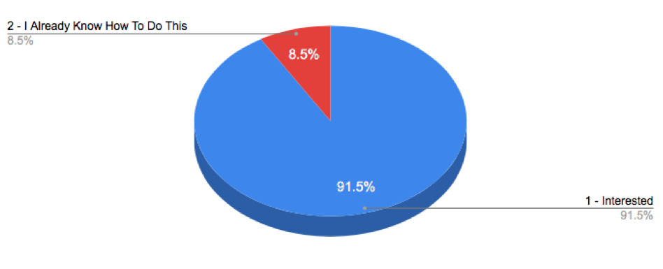

Figure 4. Are you interested in discovering new things that your device can do?

The questionnaire also revealed that 88.7% (Fig 5) are particularly keen to learn how to troubleshoot and self-diagnose technical problems with their devices. The results are depicted in Figures 1-8 in Appendix A.

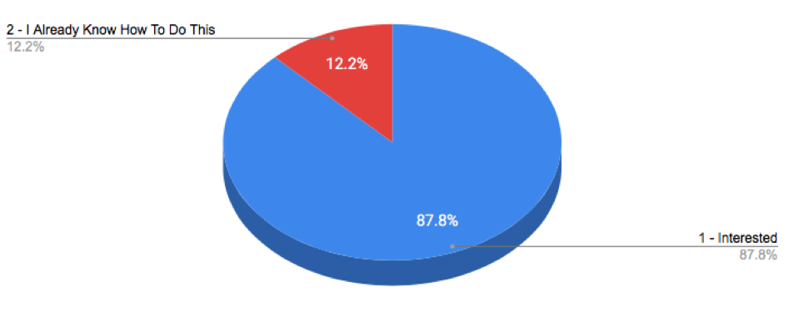

Figure 5. Are you interested in learning how to troubleshoot your smartphone or digital tablet?

The interview feedback indicated that the senior interviewed has limited technical knowledge and provided further insight to specific technical issues that she faces. The senior interviewed would welcome the senior technical empowerment classes. For responses to the interview questions see Appendix B.

## Data Sources

The data used to create this proposal came from a questionnaire “Smartphones and Digital Tablets” that was completed by seniors (55+); an interview with a senior Jan Lewis; an article on The Huffington Post’s website - “A Hot Trend: The Internet, Social Media and the Elderly”; an article on the Guardian website - “Study Finds Social Media use Beneficial to the Overall health of elderly”; research study by PEW Internet research - “Tech Adoption Climbs Among Older Adults”; an article by Courville Communities (A senior living community) - “How Seniors can Benefit from the Digital Age”; a study by PEW Research Center Internet & Technology – “Generations Online in 2010”; a study by Care at Home NJ - “Using Technology to Reduce Social Isolation and Depression in Homebound Older Adults”; an article by Sally Aquire – “Learning New Skills in Retirement”; and an article by Linda Barbarotta – “Fighting Isolation with Technology”.

## Scope and Limitations

The classes provided to the seniors (55+) will only be related to smartphones and digital tablets.

# DISCUSSION

## Method

The classes will be taught as workshops, learning by example. Handouts will be provided for each class for the seniors to follow along and complete the exercises. The classes will be split up into manageable topics therefore, preventing the seniors from becoming overwhelmed by information overload. By grouping similar topics and creating classes that explain concepts by example this will enable the seniors to learn even the most complex of topics. Handouts will be provided so that the seniors can refer to the lessons in their own time should they need a refresher.

The classes will cater from a minimum of five people to a maximum of 10 people. Keeping the small class size will ensure that the seniors get a more focused and personalized learning experience. Classes will be an hour long and will allow time for seniors to receive specific help on related issues with their digital tablets and smartphones.

## Scheduling

The classes will be ready 30 days from acceptance of this proposal. Classes will last no longer than one hour as this is an optimal amount of time to ensure that classes are effective and not overwhelming. Classes can be scheduled as frequently as you wish.

## Materials and Equipment

The equipment required would be a large room with a projector or large monitor to project the teaching materials on, a Wi-Fi connection for the class to use and comfortable seating and tables for up to 10 seniors.

## Cost

The cost to Heron’s Key will be $40 per senior per class. Each class has a minimum of five people ($200) and a maximum of 10 people ($400) per class. Classes will last one hr.

# CONCLUSION

Providing classes like these would be of great benefit to existing and future residents.

Knowing that your assisted living facility offers such classes would encourage future residents to pick your facilities over other companies who don’t offer such a service. Communication and mental well-being are key criteria for any generation but particularly seniors.

This plan will help the seniors feel more comfortable with mobile technology and remain current. Classes provided will empower the seniors to embrace technology rather than fear it. Learning in a social and fun interactive environment will greatly increase the success and participation in the classes. Seniors need to stay connected to avoid isolation and a great way to encourage this is to provide them with Technical Empowerment Classes teaching them new skills which in turn keeps their minds active.

Now is the time to empower, enable and excite your existing and future residents.

# WORKS CITED

Anderson, Monica and Perrin, Andrew. “Tech Adoption Climbs Among Older Adults”. *Pew Research Center Internet & Technology.* 17 May. 2017, [www.pewinternet.org/2017/05/17/tech-adoption-climbs-among-older-adults](http://www.pewinternet.org/2017/05/17/tech-adoption-climbs-among-older-adults). Accessed 20 Oct 2018.

Kamiel, Anita. “A Hot Trend: The Internet, Social Media & The Elderly”. *Huffington Post.* Mar 8. 2017, [www.huffingtonpost.com/anita-kamiel-rn-mps/older-people-social-media_b_9191178.html](http://www.huffingtonpost.com/anita-kamiel-rn-mps/older-people-social-media_b_9191178.html). Accessed 20 Oct 2018.

“How Seniors Can Benefit from the Digital Age”. *Courville Communities Blog.* Jan 11. 2018,

courvillecommunities.com/seniors-benefit-digital-age. Accessed 20 Oct 2018.

Morris, Steven. “Study finds social media use beneficial to overall health of elderly”. *The Guardian.* 12 Dec. 2014, [www.theguardian.com/media/2014/dec/12/study-finds-social-media-skype-facebook-use-beneficial-overall-health-elderly](http://www.theguardian.com/media/2014/dec/12/study-finds-social-media-skype-facebook-use-beneficial-overall-health-elderly). Accessed 20 Oct 2018.

Kathryn Zickuhr. “Generations Online in 2010”. *Pew Research Center Internet & Technology.* 16 Dec. 2010, [www.pewinternet.org/2010/12/16/generations-2010/](http://www.pewinternet.org/2010/12/16/generations-2010/). Accessed 20 Oct 2018.

Kent, Alex. “Using Technology to Reduce Social Isolation and Depression in Homebound Older Adults”. *Care at Home NJ.* Sep. 2017, [leadingage.org/sites/default/files/Care%20at%20Home%20NJ.pdf](http://leadingage.org/sites/default/files/Care%20at%20Home%20NJ.pdf). Accessed 20 Oct 2018.

Aquire, Sally. “Learning New Skills in Retirement”. *Retirement Mobility.* 7 Aug. 2015, [www.retirementmobility.co.uk/learning-new-skills-retirement.html](http://www.retirementmobility.co.uk/learning-new-skills-retirement.html). Accessed 20 Oct 2018.

Barbarotta, Linda. “Fighting Isolation with Technology”. *Leading Age.* 24 Jun. 2014,

http://www.leadingage.org/magazine/julyaugust-2014/fighting-isolation-technology. Accessed 20 Oct 2018.

# APPENDIX A

## Questionnaire “Smartphones and Digital Devices”

An online version of the questionnaire can be found <https://goo.gl/forms/jjDAEbQg7XQZ9R2t1>

*Required

How old are you? *

* 55-64
* 65-74
* 75-84
* 84+

How much time do you spend using yout smartphone or digital tablet? *

* Less than an hour a day
* A few times a day
* 3-5 hours a day
* I’m constantly on it
* Other

What do you predominantly use your smartphone or digital tablet for? *

* Making phone calls
* Communicating with people via video calls
* Playing games/using apps
* Watching TV, Movies
* Email
* Surfing the internet
* Taking photos or videos
* Creating documents
* Reading books with the Kindle app
* Facebook
* All of the above
* Other [Please specify]

Are you interested in learning the following? *

|  |  |  |  |
| --- | --- | --- | --- |
|  | 1.Interested | 2. I already know how to do this | 3. Not Interested |
| How to make a FaceTime/WhatsApp/Skype video call |  |  |  |
| Using the camera and photo functions on your device |  |  |  |
| Email account setup and overview |  |  |  |
| Creating social media accounts and using them |  |  |  |
| Updating your device’s firmware |  |  |  |
| Troubleshooting errors |  |  |  |
| WiFi, Bluetooth and Data |  |  |  |
| The App Store/ Google Play – Setting up and using your account |  |  |  |
| Installing games and understanding in app purchases |  |  |  |
| Discovering new things that your device can do |  |  |  |
| How to stream TV / Netflix / Prime / Xfinity / iTunes Movies |  |  |  |
| Using your device to create documents |  |  |  |

Is there anything else that you would like to learn to do using your smartphone or digital tablet that hasn’t already been mentioned above? [Your answer]

## Questionnaire Responses

The responses from the questionnaire are depicted below in Figures 1-8

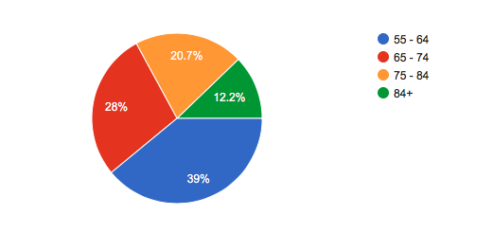

Figure 1. How old are you?

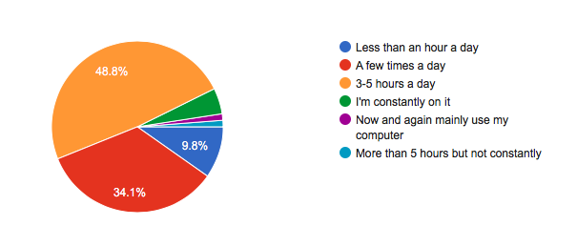

Figure 2. How much time do you spend on your smartphone or digital tablet?

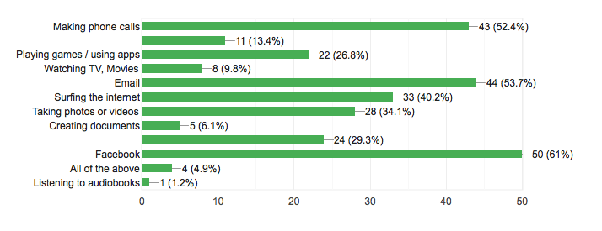

Figure 3. What do you predominantly use your smartphone or digital tablet for?



Figure 4. Are you interested in discovering new things that your device can do?



Figure 5. Are you interested in learning how to troubleshoot errors?

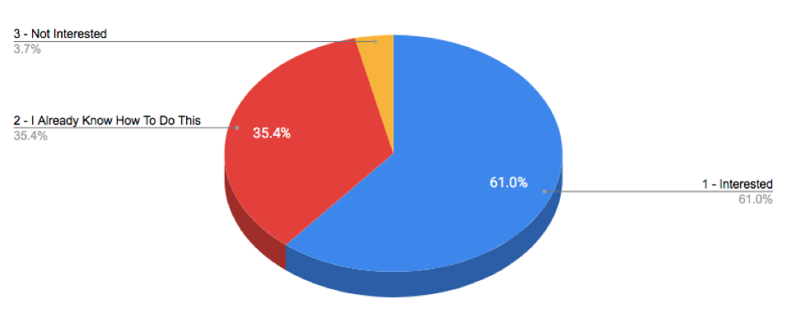

Figure 6. Are you interested in learning how to make a FaceTime/WhatsApp/Skype video call?

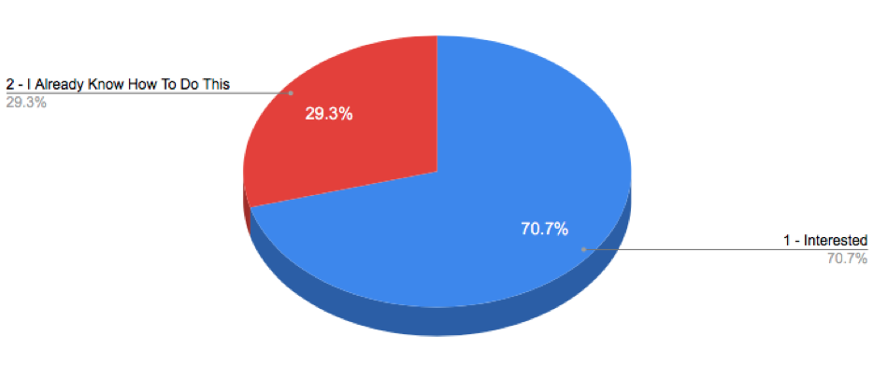

Figure 7. Are you interested in learning to use the camera and photo functions on your device?

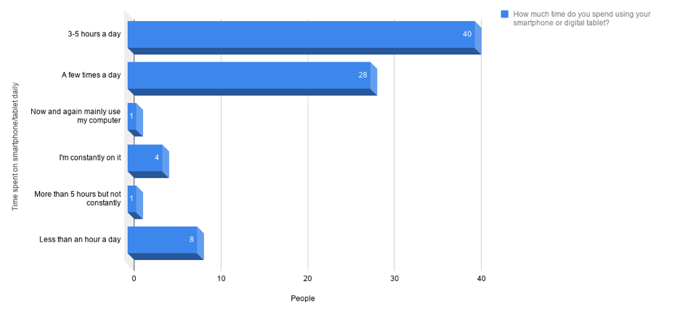

Figure 8. How much time do you spend using your smartphone or digital tablet?

# APPENDIX B

## Interview Questions and Responses

The following are the questions used to interview Jan Lewis aged 69 together with her responses.

1. How often do you use your digital tablet currently?

*“Up to 3 times a day.”*

1. Would this increase if you knew how to use more features?

*“I would be interested in learning about the available apps and tools that I’m not currently using, if I knew how to do more on my phone then I’m sure my time on it would increase.”*

1. Do you use FaceTime/Skype/WhatsApp to video call family and friends? If so how often? If not, would you like to be able to learn to do this?

“*I Only FaceTime family, my friends use messenger.”*

1. Is your cell phone a smartphone?

*“Yes, a SamsungJ3.”*

1. Do you use apps on your phone?

“*I like having instant access to my reward cards and the fact that I am kept up to date on all offers. I also play music but do not play any games.”*

1. Do you use the GPS on your phone?

“*Yes, now that I know how to use it properly it's very helpful.”*

1. Do you use the utilities such as flashlight on your phone? If not, would you if you knew where it was?

*“I didn’t realize the phone had one.”*

1. Do you use the calendar feature? If not is this something you’d like to learn?

*“Not currently but it would be a useful feature for me to learn how to use.”*

1. Do you have an email account linked to your phone? If not, would you like to know how to set it up and use it?

*“My email is working on my iPad but not on my phone, I’d like to get it set up on the phone too.”*

1. Do you surf the internet on your phone and/or tablet?

*‘Only on my iPad.”*

1. Do you take photos/videos with your phone and/or tablet?

*“I use both frequently but, I would like to learn how to organize them and create albums to share with my family on my iPad.”*

1. Do you have social media such as Facebook or Instagram on your phone or tablet? Are you comfortable using it?

*“I have Facebook but only use it on my tablet.  I do not have an Instagram account and do not know anything about this either.”*

1. How many hours a day do you use your smartphone?

“*Difficult to say - would estimate 1 hour a day as I use it more for text messages and WhatsApp.”*

1. How often do you use your phone / tablet to contact friends or family?

*“Phone constantly and with the tablet mainly on Messenger and FaceTime.”*

1. Do you instigate the calls, or do you wait for them to call you?

*“I would estimate it really is 50/50.”*

1. Do you use airline apps for boarding passes and checking in for flights? If not, currently would this be something you’d like to be able to do?

*“No, but I would like to learn how to do this.”*

1. What do you do when the Wi-Fi is not working?

*“Unplug for a few minutes and restart, if that fails I call my daughter.”*

1. What do you do when the Bluetooth device fails to pair?

*“I call my son or daughter.”*

1. Are you comfortable troubleshooting and self-diagnosing issues with your phone or tablet?

*“No, I usually consult my children.”*

1. What would you like to be able to do with your phone or tablet that you can’t currently do?

*“I would like to change the ringtones on my new phone.”*